CHRISTIE KNIGHT:
Teaching and School Support Assistant
2024

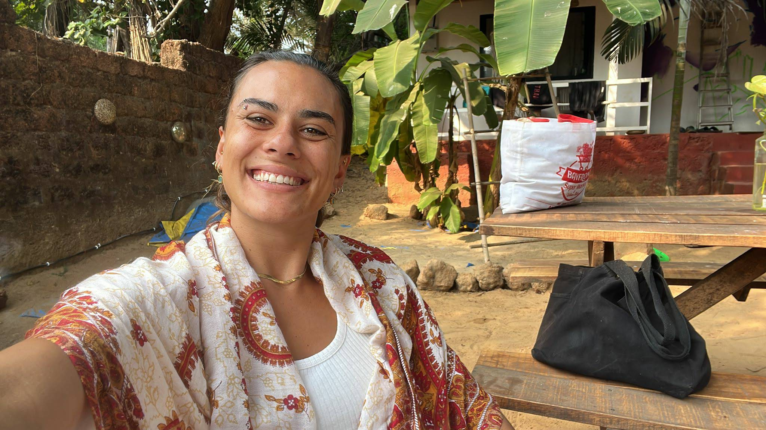
UCESCO Africa are an incredible organisation doing so much to help. During my time away from work, I wanted to spend some time volunteering and giving back to a community who need it. There are many times in our lives where someone goes out of their way to give us an opportunity, help us, or simply be there as a mentor / someone to talk to. I wanted to be able to give back and spend some time with children in Nairobi, Kenya. as you are preparing to volunteer with UCESCO Africa, I can recommend doing some extra fundraising for them. It’s easy to close your eyes to what’s really going on, as we all have been guilty of doing, but I promise that every penny you can spare for UCESCO Africa will go towards food for the vulnerable children they are serving, as well as supporting the fees to keep the kids in school. Education is key to growth and change, and UCESCO Africa is an incredible organization doing so much to help. A little goes a LONG WAY! School fees for a primary school student for a year are 7,000 Kenyan Shilling = £35. For a secondary student, it’s 30,000 Kenyan shillings = £165. Even the price of your morning coffee could feed a child at UCESCO Africa School for a week!!!!!. Safe journey. you won't regret it.

Jakob Zuegg
Sports & Recreation Coaching Assistant
2023

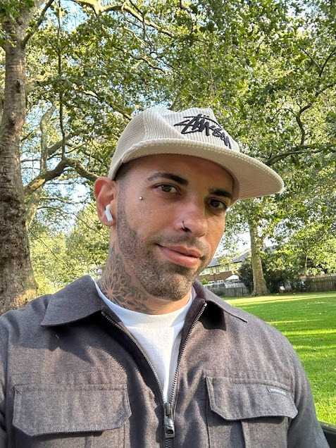
Experience of a lifetime
A wonderful program with lots of opportunities to improve the lives of kids and communities in Kenya. Hard-working and kind staff who are always open to suggestions and feedback. Definitely coming back ASAP to continue working on some of these projects closest to me. The country and the people are simply wonderful. Thanks, UCESCO for giving me this opportunity, and thanks to all the amazing volunteers I've met and become friends with. Many of my future holidays will consist of visiting Kenya and UCESCO.

Marja Talikka
Teaching and School Support Assistant
2023

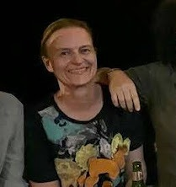
Exceeded my expectations
At 54, it was my first time volunteering and my only regret is that I didn't do it sooner. With UCESCO, everything was well taken care of. I lived in a building with other volunteers, who were btw just amazing!!! Bonding among volunteers was facilitated by shared meals, prepared by a very special local lady, who also supported us in many other ways. This allowed me to focus 100% on the project (teaching in high school). Most UCESCO people I worked with, used to or still live in the slums, so their involvement is selfless and truly comes from the heart. I have now witnessed firsthand how a small NGO works and can highly recommend volunteering with UCESCO. Their work addresses a major problem in Africa, and seeing this work from the ground was an amazing experience.

Paulina Schulte-Vels
NGO Management, Media & Administration Assistant
2023

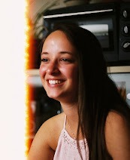
Very special experience!
I volunteered with UCESCO Africa for almost 2 months and it was a very special and awesome experience! I helped out in community service in Kibera and witnessed the impact that UCESCO Africa makes in their community every day. Being a part of this felt very special. During my time with UCESCO, I was able to meet a lot of amazing people, as well as get to know the Kenyan culture better. I can definitely recommend choosing UCESCO Africa: they have a variety of programs, great people to work with, and always made sure I was safe! Pros - safety - fun - impact.

Adamo Valtiner
Mental Health & Psychology Counseling Supporter
2022

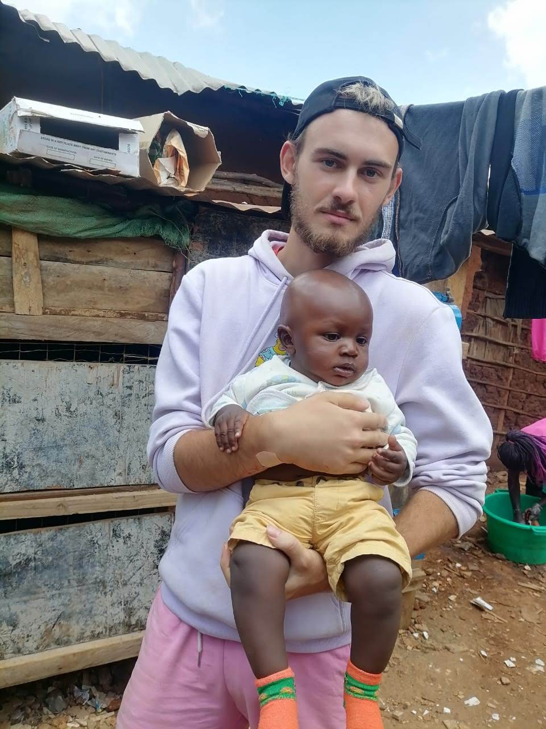
Time of my life
Hey guys! My name is Adamo. I had the honor to stay 2 months in Kenya with UCESCO. First, I am 19 years old and was scared to go out of that well-known comfort zone. Going abroad on your own into the unknown was scary. What have I heard? It is dangerous to go to Africa. It is highly risky to go to the slum. You will get diseases, you might get murdered or at least robbed. Pretty motivating huh?:) You know what? Nothing of that happened - I am still alive. The opposite happened. I recognize one day Kingsley asked me: how was your day in Kibera (the slum)? I looked at him and said quite surprised: It was great - they are just humans - as I am. These people there are humans as we are with all their needs, all their bad and positive sides. I spent over 50 days in Dreams of hope. It is a girl's center with over 70 girls from the bottom of society. This is the place where dreams come true and hope is the only thing that makes these kids believe they can do EVERYTHING! Many things happened there. We danced, I gave them lessons about self-esteem, dreams, or mindset, we played football, sang together, and get to know each other. I explored myself. I visited dozens of homes and these girls showed me who they are. Who I am. You will see something. Life is short. Life is hard. Life is incredibly hard. And you know what? They fight! Every day.... they have to. But they still smile :) Every f*cking day. This changed me. The way how I see the world. After these 2 months, something happened - strangers turned into friends. These friends turned into family. And family is all you need. Thank you for that time! Thanks to UCESCO. They support you and show you the real Africa. If you want some luxury fake Africa search somewhere else. Here you will get the security you need, the support you need, and the structure you need. But: You have to make it your adventure! Want to hear some advice from me? Either way, I will tell you: Be open-minded - be yourself - be free. It is your life and I promise you - you can change a lot. There are people need you now! Start to change something! It's time for Africa ;)

Guillaume Boulland
Samburu School Renovation & Construction Assistant
2025

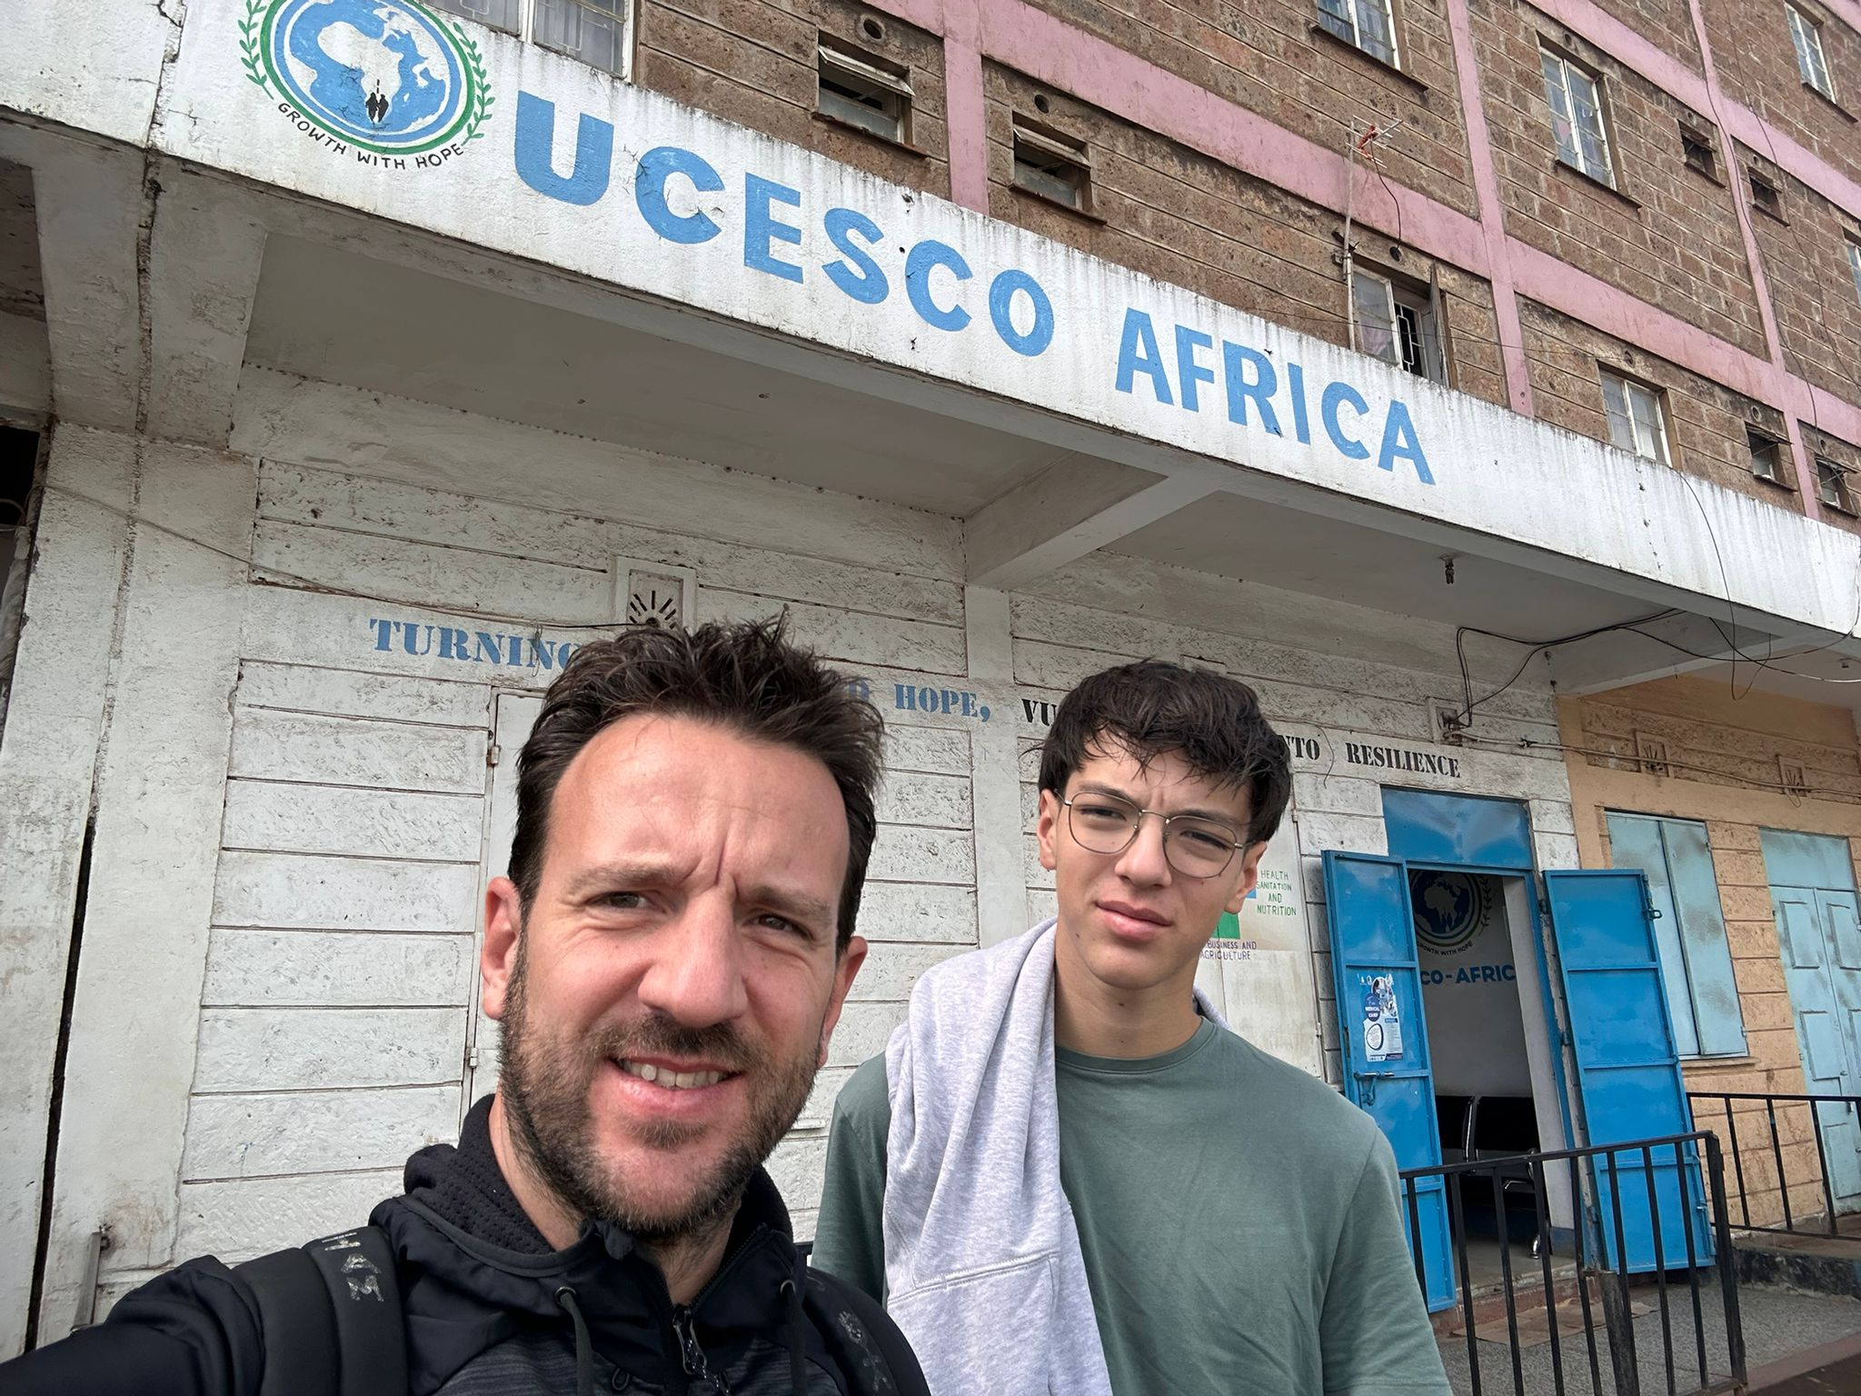
Thank you for this incredible experience 🙏
Everything was perfect: the organization, the atmosphere, the people… Everyone was so kind, thoughtful, and welcoming. It was pure bliss from beginning to end! I went on this experience with my 16-year-old son, who learned so much about others and about himself. We're returning home with hearts full of wonderful memories and deep gratitude. A huge thank you for this incredible experience in Kenya 🙏 Everything was perfect: the organization, the atmosphere, the people… Everyone was so kind, thoughtful, and welcoming. It was pure bliss from beginning to end! I went on this experience with my 16-year-old son, who learned so much about others and about himself. We're returning home with hearts full of wonderful memories and deep gratitude.

